Stakeholder and Materiality Assessment: Bell Canada
Student’s Name
Institutional Affiliations

Stakeholder and Materiality Assessment: Bell Canada

Stakeholder Identification & Assessment

Stakeholder Identification

Stakeholder Assessment
Stakeholder Impact on Company
Stakeholder Influence over Company
Company Impact over Stakeholders
Manage Closely
Keep Satisfied
Keep Informed
Monitor
Company Impact on Stakeholder
High
Low
Low
High
Competition
Community Investments
NGOs
Rating Agencies
Civil Society
Investors
Supply Chain
Team Members
Customers

Ranking | Stakeholder | Explanation
1 | Shareholders | Bell is Canada’s communications industry leader for over 136 years. Bell continuously transforms itself to deliver more value its shareholders. The shareholder return in 2017 was 9.2% past ten years was 283.2%. The increase in dividend/common share for 2017 was 5.2% and the past decade was 2008 107%  With addition of over 1.26 million new broadband customers in 2017, the postpaid wireless, Internet, IPTV, media growth services drive the steady increase in revenue, adjusted EBITDA, free cash flow that offer the financial flexibility for investing in company growth. The total revenues in 2017 was 22,719 million and net earnings was 2,970 million.
2 | Team Members | Bell is named as one of Top Employers in Canada. In 2017, the company hired more than 1000 students  In 2016, the firm made a volunteer $250 million contribution to solidify pension plan that are now subsidised at 99% on solvency basis. Joined 30% Club to aid in the acceleration of progress towards better gender balance. 82% of employees are proud to work for Bell  Bell increased its investment in staff training by 8% employee. Lowered lost-time accidents by 41% for the construction teams that build new networks
3 | Customers | Bell continuously transforms itself to deliver more value its shareholders The firm is at the forefront of the broadband revolution, provision of consumers and businesses with an extensive range of progressive networks that deliver a wide suite of communication services that improve the lives of Canadians at work, home, and play.  Bell is the industry leader in the growth in communications services today and tomorrow – Wireless, Internet, TV and Media.  The services range from high-speed Fiber Internet, Fiber TV, and Satellite TV, wireless services from Mobility Inc. and Virgin Mobile Canada, and Home Phone, and long distance.
4 | Supply Chain | Bell carefully monitors and manages its supply-chain issues as it is especially important since the firm does not manufacture the physical devices needed for the services offered to its customers. Bell purchases products from a limited amount of manufacturers, some dominate the global markets. Bell supply chain management evaluates the level of risks of major suppliers and implements mitigation measures at the contract phase to improve its resilience to possible risks. The Supplier Code of Conduct reports issues in the supply chain like Freely chosen engagement, Non-discrimination , avoidance of Child labour, Freedom of association, collective bargaining of working hours, wages, and other benefits
5 | Community Investments | In 2017, Bell’s Let’s Talk commitment to the Canadian mental health is at present $93,423,628. The firm invests over $500 million in R&D annually. There are 28 secure data centres in Canada. In 2016, over 1,790,000 Canadians has received help through various programs that were subsidized by Bell Let’s Talk. The members had totaled over 336,000 volunteer hours at the end of 2016. During the period, 1993 to 2016 Bell has donated over 90,000 used computers and 4,500 printers to various schools

Materiality Assessment









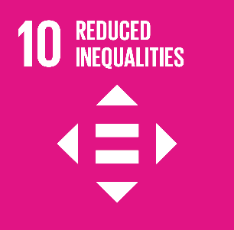
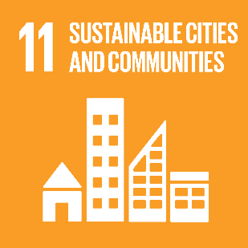


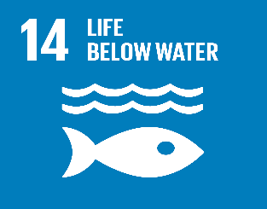


Company Impact on SDG
SDG Impact on Company
Low
High
High
Low

Ranking | SDG | Concerned Stakeholders | Explanation
1 | 8 | - Employees  - Customers  - Investors  - Supply Chain  - Local Community | Promotion of sustainable, inclusiveness and sustainable economic growth, full, productive employment, decent work for everybody. Bell provided well-paying and highly skilled jobs, thus contributing to 2 targets connected to this goal:  - Attain higher economic productivity: diversification, technological upgrade and innovations  - By 2030, attain full, productive employment, decent work for women and men(young people, persons with disabilities) equal pay for equal value work  - Bell is responsible for its procurement & stewardship programs. Improve progressively till 2030 to ensure that global resource efficiency in production and consumption and endeavouring to decouple the economic growth, environmental degradation, sustainable production and consumption and, with developed nations taking the lead.  - The supplier’s code of conduct focuses on child labour in supply chain by imposing effective measures for the eradication of forced labour, ending modern slavery, human trafficking and securing the prohibition and eradication of the worst kinds of child labour, like child soldiers.  - The occupational health & safety programs protect the labour rights and aid in the promotion of safe & secure working environments for the entire workforce
2 | 2 | The community  Investors  Employees | Ending hunger, achieving food security and improving nutrition & promoting sustainable agriculture. The products contribute to two targets for the goal:  - By 2030, the company will double its agricultural productivity and total incomes of small-scale producers, particularly women, indigenous people, family farmer, pastoralists, fishers, including through safe and equal access for land, productive resources, inputs, knowledge, financial services, markets, opportunities for addition of value and non-farm employment  - By 2030, make sure sustainable production systems and implementation of buoyant agricultural practices that grow productivity and production, that aid in maintaining ecosystems, strengthening capacity for the adaptation to climate change, extreme weather, drought, flooding and disasters that increasingly improve quality of land and soil
3 | 5 | NGOs  Investors  Community | - Attain gender equality & empowering women and girl. Bell’s diversity & leadership programs subsidize to two targets for the goal:  - Ending forms of discrimination alongside the women and girls universally  - Ensuring women’s full & effective involvement and equal opportunities for all leadership in all levels of decision-making political, economic & public life  - Bell’s products contribute to one target for this goal:  - Enhancing the usage of enabling technology, particularly, information & communications technology for the promotion the women empowerment
4 | 9 | - Investors  - Employees  - Supply chain  - Environmental Agencies | - Building resilient infrastructure, promoting inclusive & sustainable industrialization and fostering innovation  - The participation in Artificial intelligence super-clusters and investments in R&D contribute to the target related to the goal:  - Enhancing scientific research, upgrading the technological capabilities of sectors in all nations, particularly developing nations  - At end 2030, encourage innovation and substantial increase in the number of R&D workers per 1 million persons and public and private R&D spending
5 | 12 | - Investors  - Rating Agencies  - Environmental Agencies | - Bell’s environmental action plan subsidizes to one target connected to the goal:  - By 2030, to considerably decrease waste generation via prevention, reduction, reuse, and recycling  - The company has been reporting on environmental and social performance since 1990s and the reports contribute to one target connected to the goal:  - Encourage corporations, mainly larger & transnational corporations, for adopting the sustainable practices and integrating sustainability information into reporting cycle

References
Bell Canada. (2017). Annual report - Bell Canada. Montreal: Bell Canada. Retrieved from http://www.bce.ca/investors/AR-2017/2017-bce-annual-report.pdf
Bell Canada. (2017). Corporate Responsibility Report- Bell Canada. Montreal: Bell Canada. Retrieved from http://www.bce.ca/responsibility/corporate-responsibility/2017-cr-report/2017-csr-report.pdf
Bell Canada. (2016). Corporate Responsibility Report - Bell Canada. Montreal: Bell Canada. Retrieved from http://www.bce.ca/responsibility/corporate-responsibility/2016-cr-report/2016-csr-report.pdf

